Smart Supply Chain Management: Russia - Switzerland experience.

The transformation of the modern economy on the basis of information technologies creates new economic conditions, which are called Industry 4.0. On the other hand, at the present stage of development, customer needs are increasing with respect to the level of service and the possibility of acquiring the necessary goods and services using multi- and omni - channel sales. As a result, the volumes and complexity of material and information flows in supply chains increase significantly.

New approaches to the organization of supply chains based on various “smart” technologies allow to optimize the decision-making process and reduce costs. Among such technologies, we can highlight: the Internet of things, predictive analytics, artificial intelligence, the use of drones, big data analysis, machine learning, machine-to-machine "communication", data mining, etc.

The relevance of "smart" technologies use in the commercial activities of companies participating in the supply chain has led to the search for ways of their practical application and learning international experience. The result was a joint project «Smart Supply Chain» between Samara State University of Economics and HE Arc (Neuchatel, Switzerland) in the frame of Innovation Seeds Grant.

The conference «Smart Supply Chain – How to use Big Data processing to enhance your traditional Supply Chain» was organized in Neuchatel on the 29th-30th of November and the representatives of SSEU performed the reports about the current state and trends in the development of “smart” technologies in supply chain management in the Russian market. Special attention was paid to the aspects of the development of the Internet of things technology in Russia, to the prospects and practice of applying predictive analytics, trends and barriers to the development of “smart” technologies in the supply chains in the Samara region.

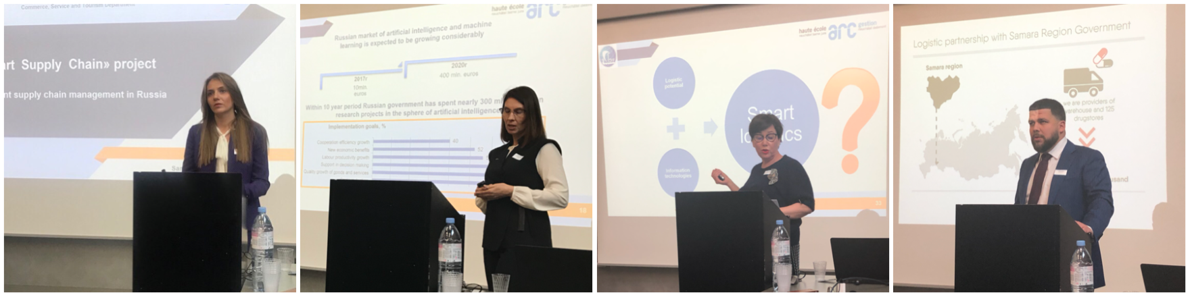

The professor of HE Arc . Karine Doan and Dr., Prof. Stefano Carrino presented reports on the current state and prospects for the application of smart technologies in supply chains, as well as the possibilities of applying data mining in modeling logistic of business processes, and held a master class on the practical application of these technologies and transformation of traditional supply chains into smart chains.

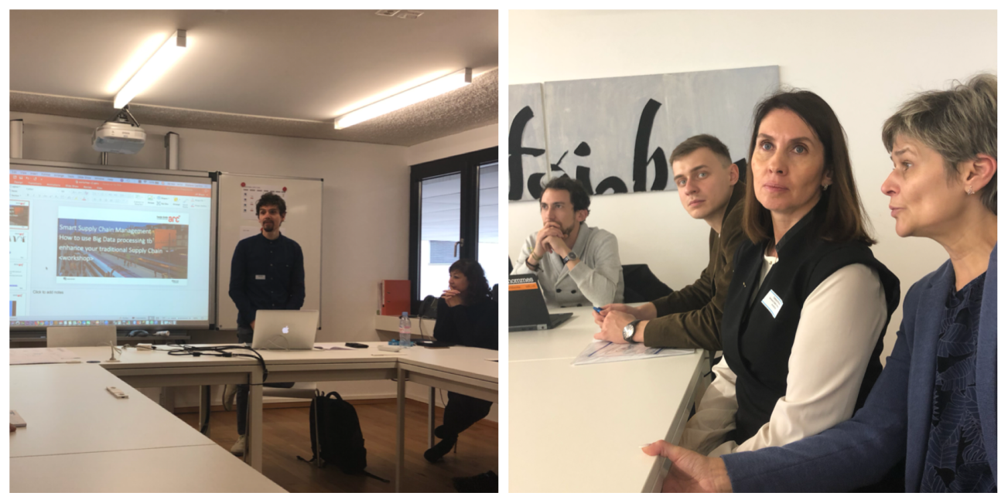

The representatives of both schools visited the company Digi Sens Switzerland AG and became more familiar with the production processes and products of the company.

